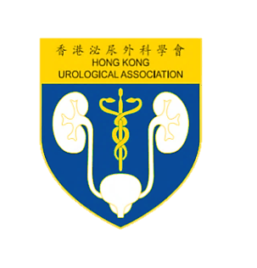

22nd Annual Scientific Meeting

20 November 2016, Sheraton Hong Kong

**REGISTRATION FORM**

**REGISTRATION FEE WAIVERS FOR HKUA MEMBERS**

**NON-MEMBER REGISTRATION FEE: HK$600**

Please complete in CAPITAL LETTERS and return to the Conference Secretariat:

Email:[hkua.conference@gmail.com](mailto:hkua.conference@gmail.com) / Fax: (852) 8344 5115

**Title :** Prof. Dr. Mr. Ms.

**HKUA Member :** Yes No

**Surname :** **Given Name :**

**Email :**

**Mobile :** **Telephone:** **Fax:**

**Correspondence address :**

**I agree to provide the above information to the Conference Secretariat for the purpose of communication.**

**Signature** **Date**

***\*If you are NOT a HKUA member, please attach a cheque for the registration fee. Please issue a cheque which should be made payable to “Hong Kong Urological Association” and send it to the below address:***

The President

Hong Kong Urological Association

4/F, Duke of Windsor Social Service Building

15 Hennessy Road

Wanchai, Hong Kong